The Network Layer

*Aayush Tyagi*

* On a local area network or LAN, nodes can communicate with each other through their physical MAC addresses. But MAC addressing isn't a scheme that scales well, every single network interface on the planet has a unique MAC address and they aren't ordered in any systematic way.
* **IP addresses** are a 32 bit long numbers made up of four octets, and each octet is normally described in decimal numbers. 8 bits of data or a single octet can represent all decimal numbers from 0 to 255.
* 12.30.56.78 is a valid IP address, but 123.456.789.100 would not be because it has numbers larger than could be represented by 8 bits. This format is known as **dotted decimal notation**.
* **IP addresses** are distributed in large sections to various organizations and companies instead of being determined by hardware vendors. This means that IP addresses are more hierarchical and easier to store data about than physical addresses are.
* IP addresses belong to networks, not to the devices attached to those networks. Many modern networks you can connect a new device and an IP address will be assigned to it automatically through a technology known as **dynamic host configuration protocol**. An IP address assigned this way is known as a **dynamic IP address**.
* Mostly, static IP addresses are reserved for servers and network devices, while dynamic IP addresses are reserved for clients. But there are certainly situations where this might not be true.
* Under the IP protocol, a packet is usually referred to as an **IP datagram**. Just like any Ethernet frame, an IP datagram is a highly structured series of fields that are strictly defined.

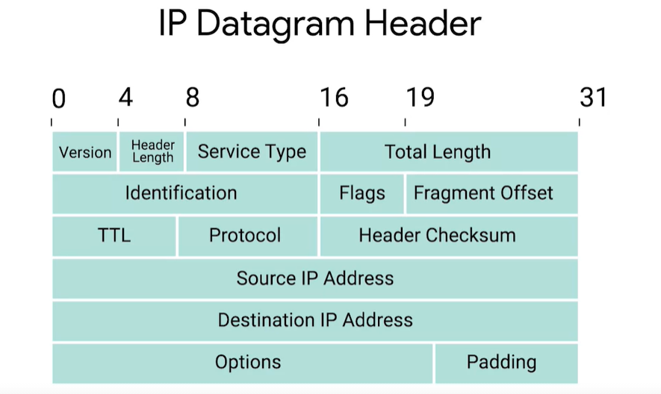

* The most common version of **IP** is version 4, or **IPv4**.
* **Header Length field**: Almost always 20 bytes in length when dealing with IPv4. 20 bytes is the minimum length of an IP header.
* **Service Type field**: These 8 bits can be used to specify details about quality of servicem or QoS technologies.
* **Total Length field**: Indicates the total length of the IP datagram it's attached to.
* **Identification field**: A 16-bit number that's used to group messages together.
* The maximum size of a single datagram is the largest number you can represent with 16 bits: 65,535.
* If the total amount of data that needs to be sent is larget than what can fit in a single datagram, the IP layer needs to split this data up into many individual packets.
* **Flag field**: Used to indicate if a datagram is allowed to be fragmented, or to indicate that the datagram has already been fragmented.
* **Fragmentation**: The process of taking a single IP datagram and splitting it up into several smaller datagrams.
* **Time to Live (TTL) field**: An 8-bit field that indicates how many router hops a datagram can traverse before it's thrown away.
* **Protocol field**: Another 8-bit field that contains data about what transport layer protocol is being used.
* The most common transport layer protocols are **TCP** and **UDP**.
* **Header checksup field**: A checksum of the contents of the entire IP datagram header.
* **IP options field**: An optional field and is used to set special characteristics for datagram primarily used for testing purposes.
* **Padding field**: A series of zeros used to ensure the header is the correct total size.
* IP addresses can be split into two sections, the **network ID** and the **host ID**.
* In IP address, the network ID would be the first octet, and the host ID would be the second, third and fourth octets.
* There are three primary types of address classes.
  + **Class A** addresses are those where the first octet is used for the network ID and the last three are used for the host ID.
  + **Class B** addresses are where the first two octets are used for the network ID, and the second two are used for the host ID.
  + **Class C** addresses, as you might have guessed, are those where the first three octets are used for the network ID, and only the final octet is used for the host ID.
* If the very first bit of an IP address is 0, it belongs to a **Class A** network. 0.0.0.0 - 127.255.255.255.
* If the first bits are 10, it belongs to a **Class B** network. 128.255.255.255 - 191.255.255.255.
* If the first bits are 110, it belongs to a **Class C** network. 192.255.255.255 - 223.255.255.255.
* **ARP**: A protocol used to discover the hardware address of a node with a certain IP address.
* Almost all network connected devices will retain a local ARP table.
* **APR table**: A list of IP addresses an the MAC addresses associated with them.
* ARP table entries generally expire after a short amount of time to ensure changes in the network are accounted for.

Subnetting

* **Subnetting**: The process of taking a large network and splitting it up into many individual and smaller subnetworks or subnets.
* Incorrect subnetting setups are a common problem you might run into as an IT Support Specialist, so it's important to have a strong understanding of how this works.
* **Network IDs** are used to identify networks, and **Host IDs** are used to identify individual hosts.
* **Subnet masks**: 32-bit numbers that are normally written now as four octets in decimal.
* A single 8-bit number can represent 256 different numbers, or more specifically, the numbers 0-255.
* The network ID is always either 8 bit for class A networks, 16 bit for class B networks, or 24 bit for class C networks.
* **Demarcation point**: To describe where one network or system ends and another one begins.
* Take for example a **class A** address which uses 1 byte for the **network ID** and 3 bytes for the **Node ID**. Written **Net.Node.Node.Node**
* It is important to understand that the network part of the address is only used for**routing IP packets** on the public internet.
* Once the packet **enters the private network** then the **Node address is used** and the public Network address is not used.
* Now a network administrator can interpret the node address any way they want, and so it is possible to **split the node address** into **subnet and Node**. So we could have
* **Net**.**Subnet**.**Node.Node** or **Net**.**Subnet.Subnet**.**Node.**
* The technique used to create subnets is to use a Mask.
* Reference: <http://www.steves-internet-guide.com/subnetting-subnet-masks-explained/>

Routing

* The way communications happen across all these networks, allowing you to access data from the other side of the planet, is through **routing**.
* **ROUTER:** A network device that forwards traffic depending on the destination address of that traffic.

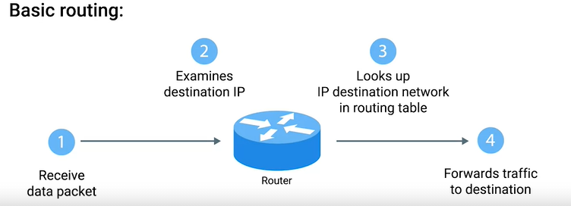

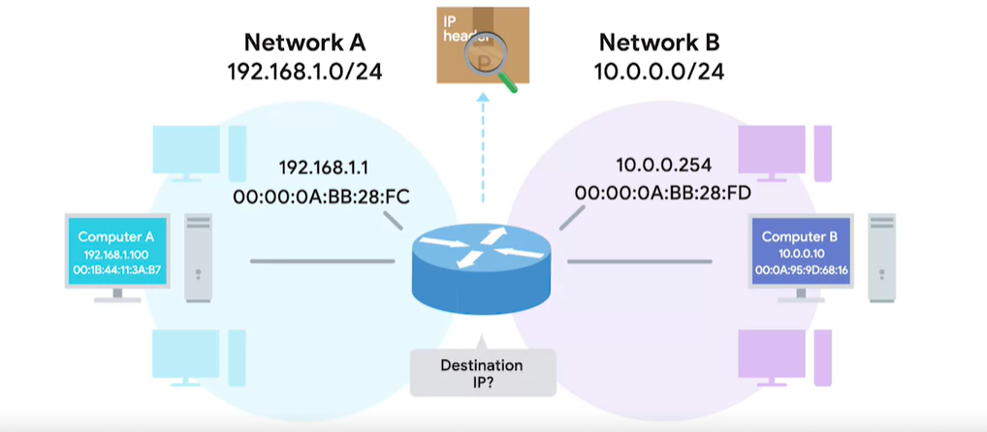

* Along with managing IP address allocation, the **IANA** is also responsible for **ASN**, or **Autonomous System Number** allocation.
* **Autonomous System Number (ASN)**: Numbers assigned to individual autonomous systems.
* **Transport layer**: Allows traffic to be directed to specific network applications.
* **Application layer**: Allows these applications to communicate in a way they understand.